Professor Bin Cheng (1921-2019)

It is with great sadness that ISPL reports the death of its great friend and Honorary President, Professor Bin Cheng, the most long-standing and distinguished academic in public international law. He died of natural causes in London on Wednesday 16 October 2019 at the age of ninety-eight.

Bin was a world authority on international air and space law. His many publications in public international law and its application to space activities are some of the most important writings on the subject and will be a benchmark source of reference for many years to come. His advocacy of the civilising benefits of international law, his teaching at UCL, as Professor and Dean of the Law School, and universities around the world inspired his own and succeeding generations of academics and lawyers. In retirement Bin continued his invaluable contribution to the field as Emeritus Professor, and speaker at international fora.

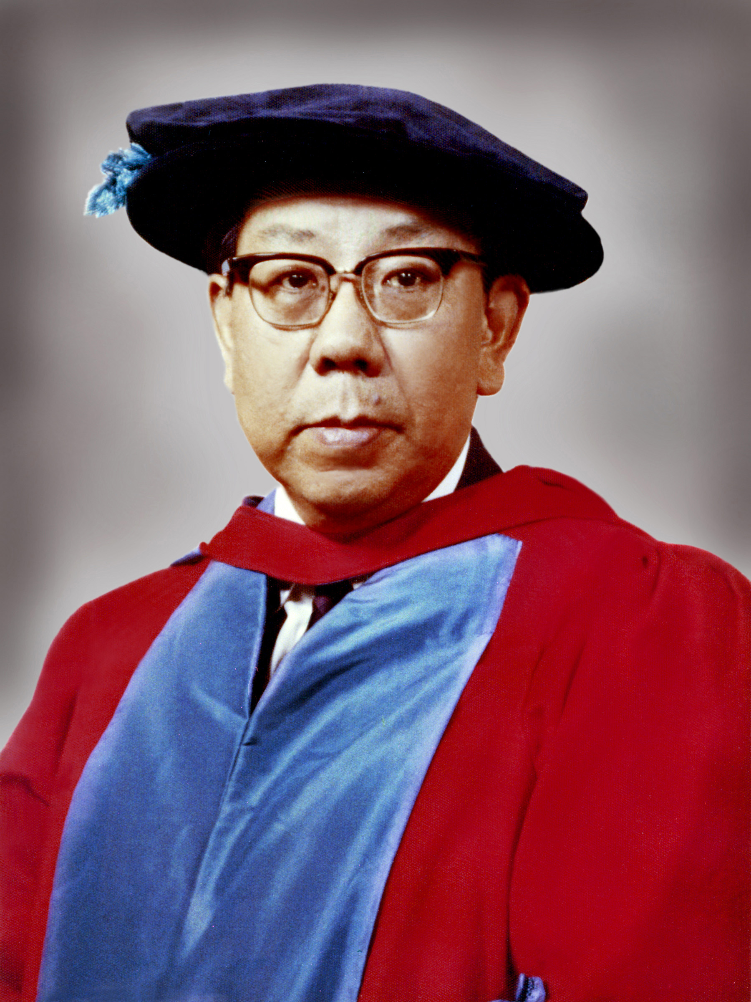

His numerous honours and his post-retirement contributions to the development of international law evidence his valued pioneering, insightful thinking in a lifetime devoted to creating a new branch of international law.

Bin's many accomplishments are matched only by his modesty and willingness to assist and encourage young lawyers and others. He was unfailingly modest, charming, courteous and gentle in all his dealings and was also great fun to be with.

It has been a great privilege for us to know Bin for about 40 years. We always felt rewarded when, attempting an observation on a point of law, he replied with a trademark wink of his eye, "That's right because, you know,…" at which point, with disarming charm and wit, his fuller understanding of the point came through.

In 2008 he honoured ISPL by accepting the honorary presidency of the London Institute of Space Policy and Law. Bin's invaluable advice and encouragement have been central to the progress of the Institute.

Bin is survived by his wife Katherine and their family. We shall all miss him greatly.

