HARMFUL INTERFERENCE Case Study
This cased study describes the current situation in terms of Harmful Interference (HI) incidents reported to the Radiocommunication Bureau, the regulatory provisions applicable and possible limitations encountered by administrations when seeking to resolve such cases.
It ends with a few key messages in the form of guidelines to stakeholders involved in satellite services, the aim being to tackle the problem of harmful interference in such a way as to minimize its impact by implementing synergistic and continuous action and cooperation between all involved players.

1 INTRODUCTION TO THE INTERNATIONAL REGULATORY FRAMEWORK

The ITU Radiocommunication Sector is committed to maintaining right of access and efficient use of the orbit/spectrum resource; to contributing to ensure that the benefits of economies of scale, interoperability and roaming and global harmonization are reaped; to providing guidelines for national and regional regulations; and to maximizing operation free from harmful interference. This virtuous mechanism is supported by international regulations, global standards, guidelines and the assistance by the Radiocommunication Bureau. In other words, in terms of satellite communications, interference-free operation maximizes quality of service and prevents loss of investment, customers and revenue by minimizing the amount of satellite capacity that is unusable due to the harmful interference.
2 THE FACTS:
1. Earth Stations (ES) User 1 and User 2 and Satellite A of Administration (ADM) A is located at a given orbital location of the GSO arc.
2. ES User X and Satellite B of ADM B is located at a given orbital location of the GSO arc.
3. ES User 1 carries fixed satellite data to ES User 2 at service area of Satellite A.
4. ES User X (ADM B) transmits a signal, either continuously or intermittently, that causes harmful interference to Satellite A of ADM A that severely disrupts the signals carrying the programme into the whole of the service area of Satellite A. Hence the ES Users 1 and 2 in the service Area A may not be able to receive the intended information.
5 The interfering signal may also cause other issues: such as technical damages to the satellite receiver of Satellite A; revenue losses to the client of the operator of ES User 1 and 2, and revenue losses to the satellite operator of Satellite A who might lose his clients.

3 QUESTION:
- What law and jurisdiction apply?
- What recourses are available to ADM A and to the Satellite Operator A and ES User 1 and 2?
- What will go on if a Satellite Operator B of ADM B DOESN’T respond to satellite operator A of ADM related to its request to solve a case of HI ?
- Does the satellite operator A and ADM A right to request the ITU for assistance/help in this issue?

Note: Its Constitution (CS) and Convention (CV) govern the ITU.

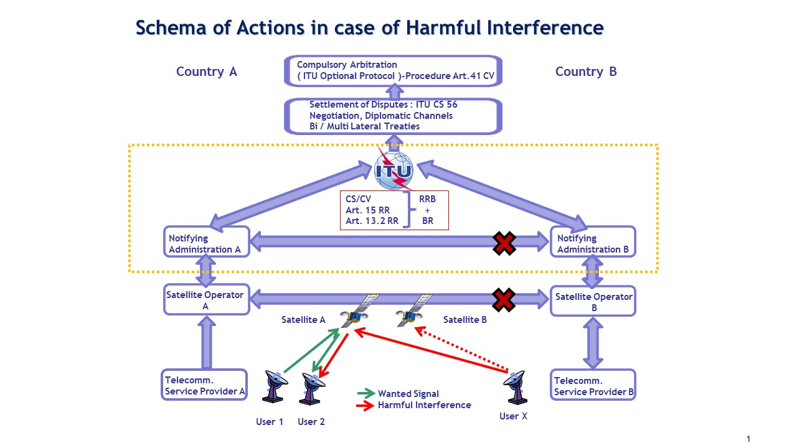

4 DISCUSSION
- The questions to be answered are

- How do we define “harmful interference”?
- What law applies? What recourses are available to the administrations/satellite operators A and B?
- To answer this we would first have to look at what ITU procedures and processes apply when trying to resolve a “harmful interference” incident?
- If we then find that ITU cannot enforce its will on countries, especially in such jamming cases, what other legal course of actions can be found and applied?

5 DEFINITIONS:
The international regulatory framework is provided by a set of legal instruments that include the ITU Constitution (CS), Convention (CV) and Radio Regulations (RR) that have the status of intergovernmental treaties and are legally binding on all Member States. They define the objectives, rights and obligations of parties.

Article 1 of the CS states that “The Union shall… effect allocation of bands of the radio-frequency spectrum, the allotment of radio-frequencies and the registration of radio frequency assignments and, for space services, of any associated orbital position in the geostationary-satellite orbit or of any associated characteristics of satellites in other orbits, in order to avoid harmful interference between radio stations of different countries.”
and
Article 45 of the CS states that: “All stations… must be established and operated in such a manner as not to cause harmful interference to the radio services … of other Member States or of recognized operating agencies, or of other duly authorized operating agencies which carry on a radio service, and which operate in accordance with the provisions of the Radio regulations.”
and
Article 8 of the RR states that: When using the orbit/spectrum resource, Member States have the right to international recognition and protection of those frequency assignments successfully coordinated and recorded in the Master International Frequency Register (MIFR), and the obligations to license transmitting stations, to coordinate frequency assignment sharing with other administrations and more importantly to immediately take necessary actions to stop the signal from causing harmful interference.

Some of the devices of this complex regulatory mechanism designed to ensure equitable access and adequate control of interference are listed below:
– allocation of frequency bands to different services;
– power limits: in general, power flux density limits to protect terrestrial services, e.i.r.p.limits to protect space services, EPFD limits to protect GSO from non-GSO;
– coordination between administrations to ensure interference-free operating conditions;
– recording of frequency assignments in the MIFR to obtain international recognition and protection;
– monitoring to verify compliance with the Radio Regulations (RR) and resolve cases of harmful interference.

6 THE MAIN ASSOCIATED PROVISIONS OF THE RADIO REGULATIONS MAY BE FOUND IN:

– Article 4: General provisions to prevent harmful interference

– Article 5: Table of Frequency Allocations – individual conditions in the footnotes

– Articles 7, 8, 9, 11: Coordination/notification procedures

– Articles 21 and 22: Power limits

– Appendices 30/30A/30B: Plans and associated procedures

– Provisions Nos. 11.42, 13.2, 13.6 and Articles 16 and 18 regarding obligations, cooperation, assistance, international monitoring, licensing and identification of stations;
and for the provisions more related to harmful interference in:

– Sections VI of Article 15: Procedure in case of harmful Interference

– Section V of Article 15: Reports of Infringements

– Section I of Article 13: Assistance by the Bureau

– No. 7.8, No. 8.5, No. 11.42, § 4.1.20/4.2.21D of AP30/30A

– Appendix 10: Report of harmful interference, and

– Report ITU-R SM.2181 for the submission of reports of harmful interference to the Radiocommunication Bureau.
In this context, it should be noted that there is no real enforcement mechanism in the current regulations, apart from Article 56 of the ITU Constitution related to the settlement of disputes and the Optional Protocol (see paragraph 3 below).

7 CURRENT RR SOLUTION IN CASE OF HI
Based on the RR Appendix 10 Reports and additional frequency/spectrum plot and geolocation should be submitted by administration A to administration B and with a copy to the Bureau (see samples next page).
The reasons for the harmful interference affecting satellite services could be divided as follows:
– No coordination: cases of harmful interference caused by the operation of uncoordinated frequency assignments (very often a fait-accompli approach by operating a space station under an ITU satellite network recorded or in the process of being recorded in the MIFR without having initiated the normal and mandatory coordination process under the ITU framework);
– Unauthorized use: accessing transponders without the required authorization, either accidentally or deliberately (very common reasons for accidental cases include equipment failure, human error, improper commissioning, interference from proliferation of terrestrial (e.g. microwave) systems; deliberate interference are generally caused by unauthorized “borrowing” of bandwidth for test purposes (e.g. at commissioning), piracy, hostile attempts to deny service, becoming more prevalent though geopolitical motivation);
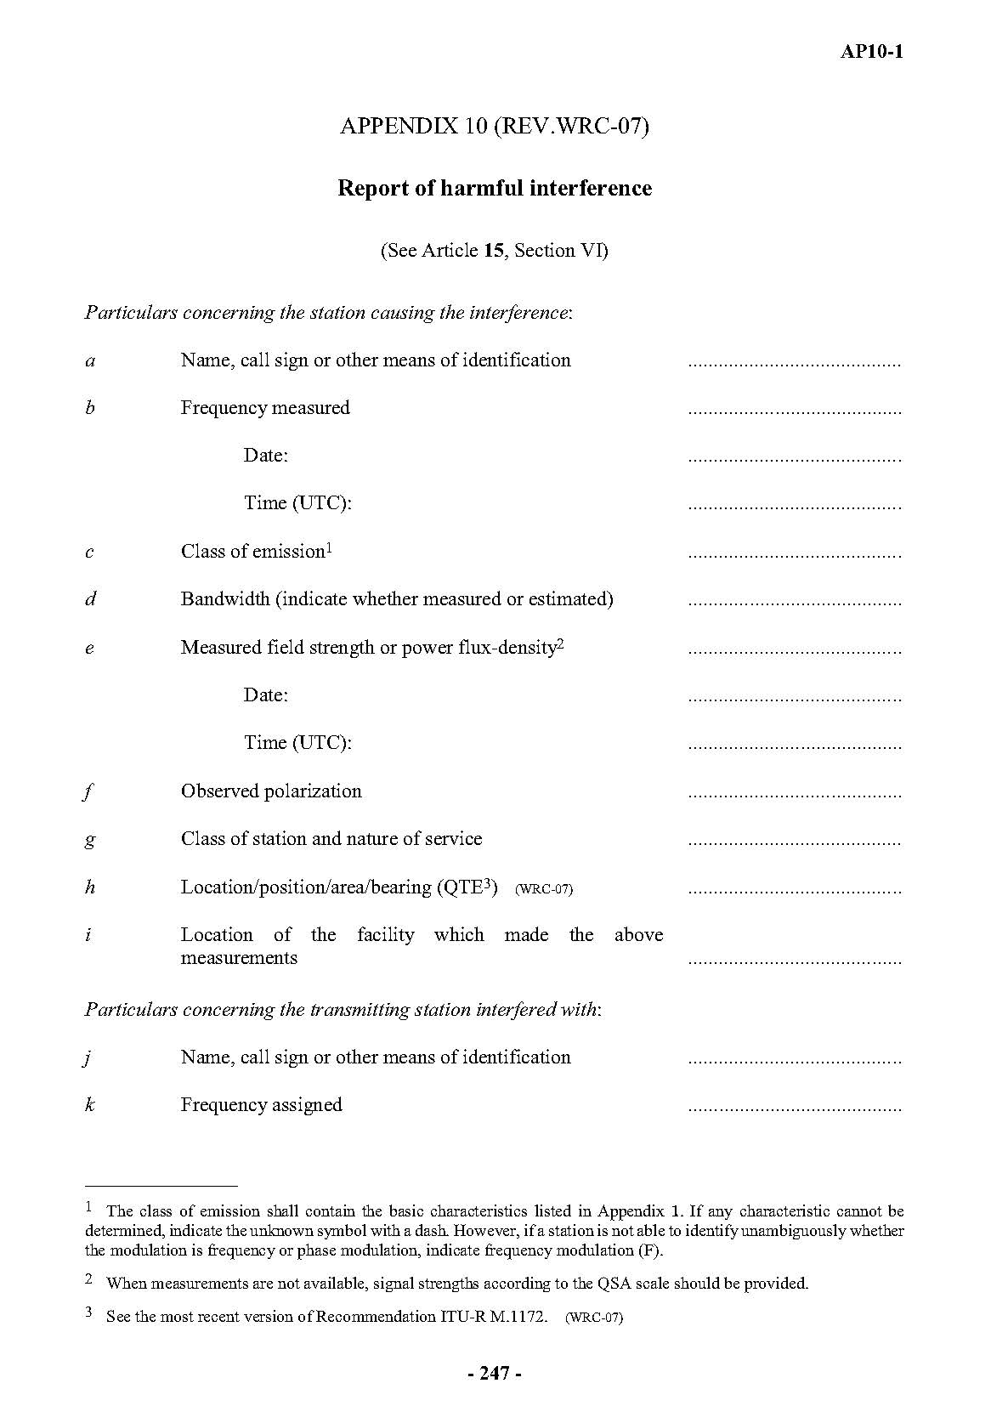
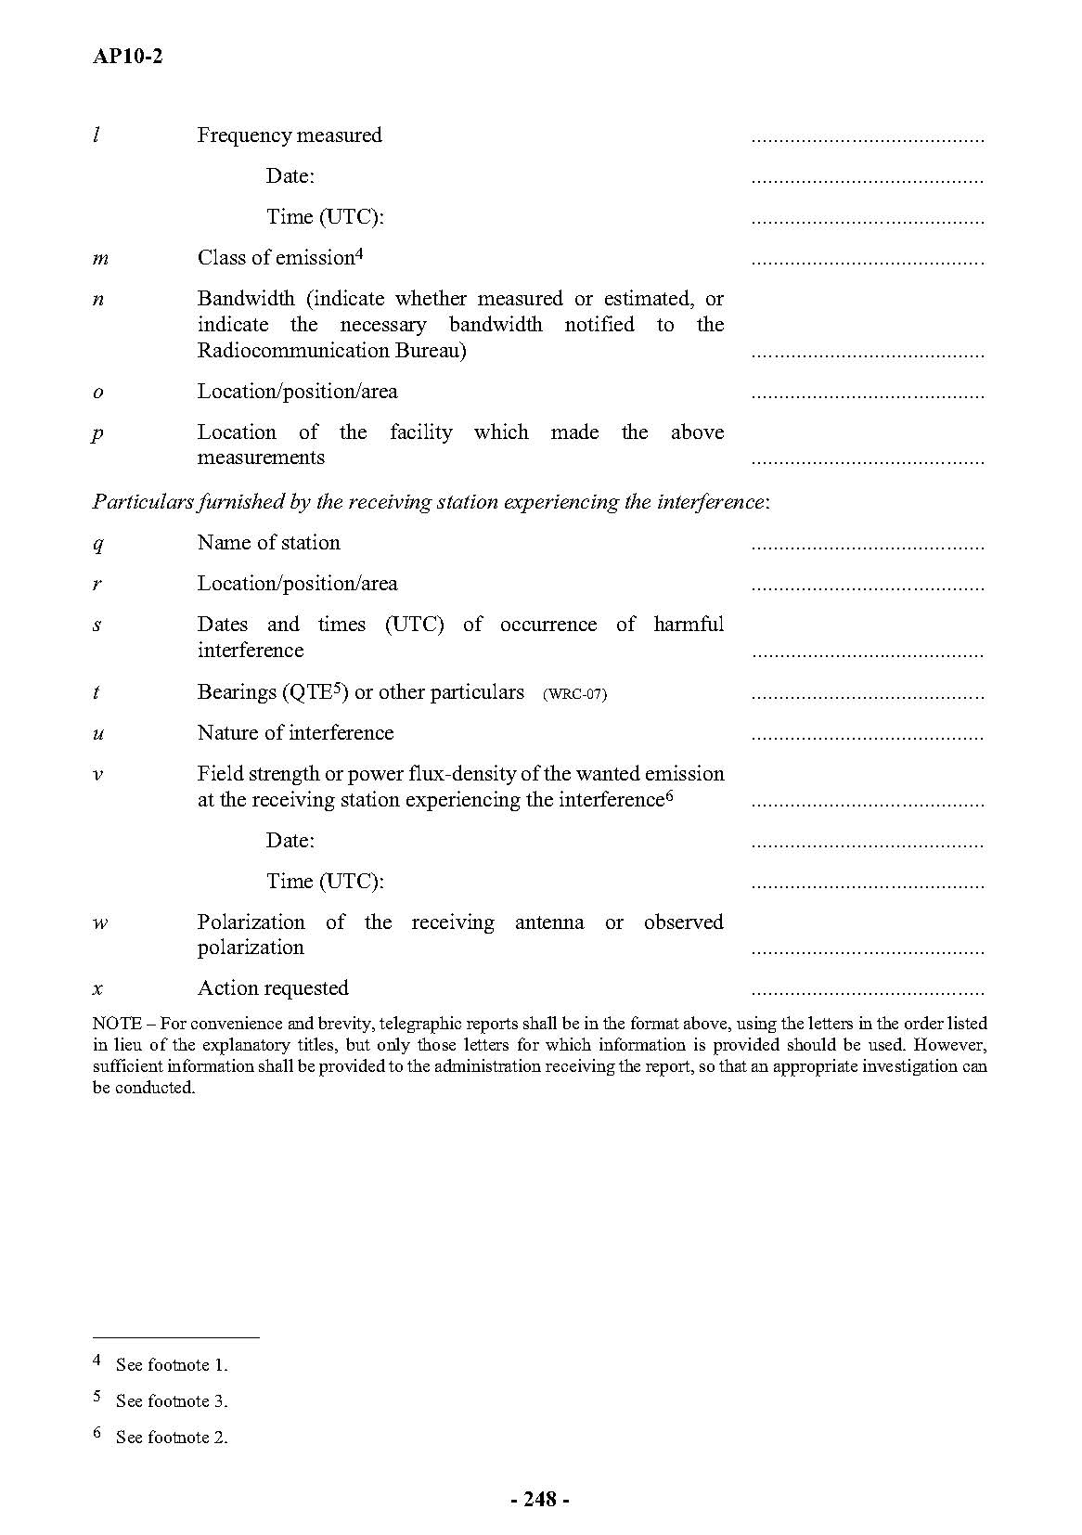

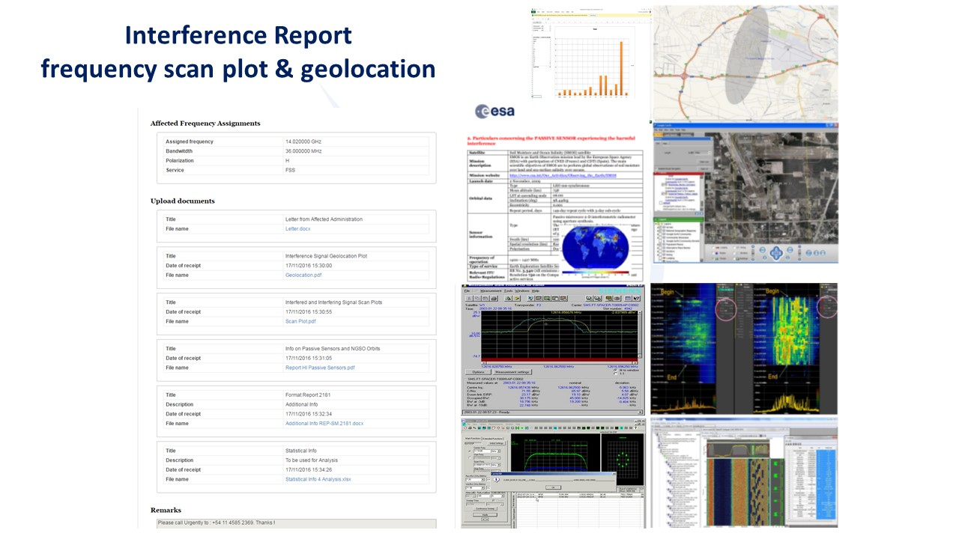
– Unnecessary transmission: cases of harmful interference as described in RR No. 15.1:
“All stations are forbidden to carry out unnecessary transmissions, or the transmission of superfluous signals, or the transmission of false or misleading signals…”.
Typically, this refers to harmful interference caused by a high-power Carrier Wave (CW), which is believed to be deliberately transmitted in some circumstances;
– Technical or operational: spurious emissions, excessive transmitting power, transmitting stations that are not in conformity with frequency tolerances, miss-pointing of antennas associated with earth stations, cross-polarization interference or interference due to transponder saturation, for example, and
– Regulatory: out-of-band operations not authorized by the Radio Regulations, or exceptionally under a non-interference/non-protection basis.
The most frequently affected services include the broadcasting-satellite service, fixed-satellite service and mobile-satellite service. However, with fewer occurrences, harmful interference also hits earth exploration-satellite service and radionavigation-satellite service.
Incidents related to coordination not fully completed or event not initiated between closely separated satellite networks is a concerning issue which has drawn attention of the Bureau and deserves thorough and careful considerations.
The current definition of harmful interference in the Radio Regulations similar to the one in the Annex to the ITU Constitution (CS 1003) reads as follows:
RR No. 1.169 harmful interference:
“Interference which endangers the functioning of a radionavigation service or of other safety services or seriously degrades, obstructs, or repeatedly interrupts a radiocommunication service operating in accordance with Radio Regulations (CS).”
No distinction is made between deliberate and unintentional interference and no specific level to define when from a permissible interference (RR No. 1.167) it could be an accepted interference (RR No. 1.168) and then considered as harmful interference.
In case of difficulties between administration A and B in resolving a case of harmful interference, any administration may request assistance of the Bureau under RR No.13.2.
RR Article 13 Section I − Assistance to administrations by the Bureau
RR No. 13.2 When an administration has difficulty in resolving a case of harmful interference and seeks the assistance of the Bureau, the latter shall, as appropriate, help in identifying the source of the interference and seek the cooperation of the responsible administration in order to resolve the matter, and prepare a report for consideration by the Board, including draft recommendations to the administrations concerned.
RR No. 13.3 When an administration so requests, the Bureau shall, using such means at its disposal as are appropriate in the circumstances, conduct a study of reported cases of alleged contravention or non-observance of these Regulations and shall prepare a report for consideration by the Board, including draft recommendations to the administrations concerned.
Moreover, as mentioned above, there is no real enforcement mechanism in the current regulations, apart from Article 56 of the ITU Constitution related to the settlement of disputes and the Optional Protocol. Indeed, the utmost goodwill, mutual assistance and cooperation of Member States involved are the only current methodology specified in the regulations for the settlement of problems of harmful interference.
8 CONCLUSIONS
While recognizing that satellite systems are constantly exposed to the risk of interference, the objective is to keep such occurrences and their impact to a controlled minimum. This is achieved through a series of actions relating inter alia to the following:
– Compliance with the ITU Constitution and Radio Regulations
– Exchange of information and cooperation between administrations, satellite operators, service and content providers, industry, organizations and associations involved in satellite communications
– Utilization of ITU Recommendations, standards, procedures
– Participation in trainings
– Utilization of new technologies, including use of the international monitoring system
– Participation in and contribution to study groups and preparatory work at regional and world meetings for the upcoming conferences, presenting the respective needs and proposals for technical and regulatory solutions.

